T 01889 565 653 F 01889 567 064 | 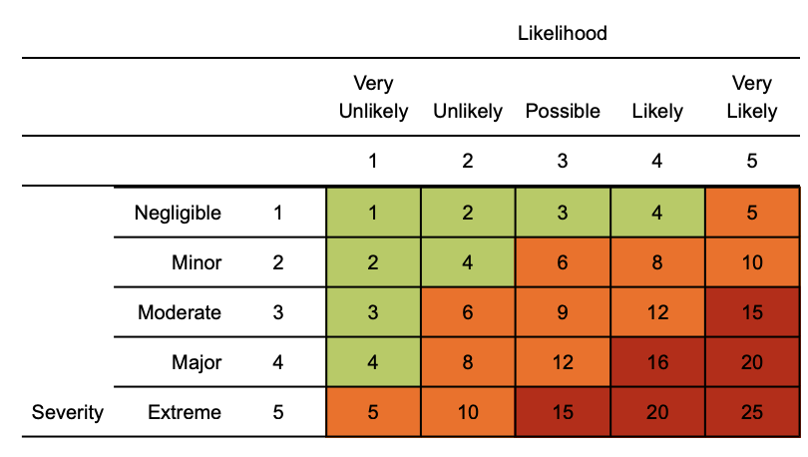  Risk matrix used in risk assessment below  RR = residual risk

Coronavirus (COVID-19) Risk Assessment
Risk Assessment for on-site Limited Production Process commencement as of 11th May 2020
Staffing levels on-site will be limited to approximately a team of 12 persons comprising of the following:
X1 Company Director, X1 Quality Inspector, X1 Planner/Client Manager, X1 Cleaner, X1 FLT/Tele Handler Operator, X1 Powder Coating Operative, X1 Shot-Blast Operative, X4-5 Small Track Production Staff.
The Risk assessment will be reviewed at frequent time intervals or for increased staffing levels.

Assessment date: 5th May 2020
- Review date: Ongoing, no greater than 6 months or where significant change has occurred

Version: 1

Hazard | Risk | Control measures | RR | Persons at risk
Exposure from others due to:  1) Living with someone with a confirmed case of COVID-19.  2) Have come into close contact (within 2 metres for 15 minutes or more) with a confirmed case of COVID-19.  3) Being advised by a public health agency that contact with a diagnosed case has occurred. | 4  x  3  =  12 | - To follow government action of self-isolation and only to leave house on the following circumstances: for medical reason; to shop for necessary food supplies; for exercise once per day; and for essential works including those deemed ‘key workers’  - Any existing individual risk assessments (disability, young persons or new / expectant mothers) to be reviewed  - Maintain contact with line management and Human Resources (HR) and to follow company policy / guidance.  - Travel is only required for essential travel; reduce the amount of time using public transport and to implement social distancing where possible (2m clearance from persons and not to travel in groups of more than 2 unless it is immediate family)  - To continue following ongoing government guidance  - Stay at home and only attend hospital in an emergency. Do not attend GP surgery and phone NHS line (111) if further advice is required  - Company to ensure extremely vulnerable persons e.g. (Solid organ transplant recipients; people with specific cancers: people with cancer who are undergoing active chemotherapy or radical radiotherapy for lung cancer; people with cancers of the blood or bone marrow such as leukemia, lymphoma or myeloma who are at any stage of treatment; people having immunotherapy or other continuing antibody treatments for cancer; people having other targeted cancer treatments which can affect the immune system, such as protein kinase inhibitors or PARP inhibitors; people who have had bone marrow or stem cell transplants in the last 6 months, or who are still taking immunosuppressive drugs; People with severe respiratory conditions including all cystic fibrosis, severe asthma and severe COPD; People with rare diseases and inborn errors of metabolism that significantly increase the risk of infections (such as SCID, homozygous sickle cell); People on immunosuppression therapies sufficient to significantly increase risk of infection; Women who are pregnant with significant heart disease, congenital or acquired.) are shielding themselves and following their specific medical advice.  - Follow good hygiene measures at all times  - Avoid all visitors to your home/ work premises unless they are providing a medical requirement  - Do not approach delivery staff, allow packages to be left on the doorstep or designated area  - Do not take any antibiotics as they do not work against viruses.  - Follow safe distance guidance from other staff wherever possible.  - Adequate PPE (personal protective equipment) will be provided where required (disposable gloves, cover alls / RPE (respiratory protection) | 4  x  1  =  4 | Individual workers
Suspected case whilst working on site | 4  x  4  =  16 | If a worker develops a high temperature (37.8c or above) & or a persistent cough while at work, they should:  - Return home immediately  - Avoid touching anything  - Cough or sneeze into a tissue and put it in a bin, or if they do not have tissues, cough, and sneeze into the crook of their elbow. (any waste should be disposed of by the correct routes, used tissues should not be left in open bins but bagged).  - They must then follow the guidance on self-isolation and not return to work until their period of self-isolation has been completed. | 4  x  1  =  4 | Individual workers
General travel | 4  x  4  =  16 | - Do not travel unless you cannot work from home or deemed a key worker where your work cannot be undertaken from home – implement teleconferencing for meetings  - Where an individual has recently visited these countries, they should self / home isolate themselves until further notice from the government (lockdown measures continue to apply)  - Continue to follow any further national government advice provided  - Where an occupational health (OH) service provider has been appointed, seek additional advice or concerns through this service  - All persons to limit their use of public transport. Where travel is essential, please use private single occupancy where possible | 4  x  1  =  4 | Individual workers
Access / egress to site | 4  x  4  =  16 | Where possible, implement the following practices:  - Stop all non-essential visitors  - Introduce staggered start and finish times to reduce congestion and contact at all times  - Monitor site access points to enable social distancing – you may need to change the number of access points, either increase to reduce congestion or decrease to enable monitoring  - Remove or disable entry systems that require skin contact e.g. fingerprint scanners (requirement for clocking in or out to be suspended until further notice to eliminate congregation of staff).  - Require all workers to wash or clean their hands before entering or leaving the site  - Allow plenty of space (two metres) between people waiting to enter site  - Regularly clean common contact surfaces in reception, office, access control and delivery areas e.g. door handles, scanners, screens, telephone handsets, desks. Reduce the number of people in attendance at site inductions /briefing sessions and consider holding them outdoors wherever possible  - Drivers should remain in their vehicles if the load will allow it and must wash or clean their hands before unloading goods and materials. | 4  x  1  =  4 | Individual workers
RPE | 3  x  4  =  12 | - Appropriate respiratory protective equipment (RPE) masks to be considered for all staff working in proximity of each other, where disposable masks are provided, they must be used correctly and the user to ensure that the mask covers the mouth and nose. People with facial hair (beards) must be informed that they may not have an adequate seal to ensure mask effectiveness. Used masks must be disposed of in a suitable bagged bin. | 2  x  2  =  4 | Individual workers
Hygiene | 4  x  4  =  16 | - Maintain good hygiene measures at all times Wash your hands thoroughly and regularly. Use soap and water for at least 20 seconds. Use alcohol-based hand sanitiser if soap and water is not available. Avoid touching your face/eyes/nose/mouth with unwashed hands and cover your cough or sneeze with a tissue then dispose of it in a suitable bagged bin.  - Provide adequate hand washing facilities Regularly clean the hand washing facilities and check soap and sanitiser levels  - Provide suitable and sufficient rubbish bins for hand towels with regular removal and disposal.  - Sites will need extra supplies of soap, hand sanitiser and paper towels and these should be securely stored.  - Restrict the number of people using toilet facilities at any one time. (staff to be informed not to congregate within the toilet facilities). Wash hands before and after using the facilities Enhance the cleaning regimes for toilet facilities particularly door handles, locks and the toilet flush Portable toilets should be avoided wherever possible, but where in use these should be cleaned and emptied more frequently | 4  x  1  =  4 | Individual workers
Canteen - exposure from large numbers of persons | 4  x  4  =  16 | - The workforce should also be required to stay on site once they have entered it and not use local shops.  - Dedicated eating areas should be identified on site to reduce food waste and contamination  - Break times should be staggered to reduce congestion and contact at all times  - Follow personal hygiene rules when leaving the work area and thoroughly was their hands. Workers should sit 2 metres apart from each other whilst eating and avoid all contact  - Company Crockery, eating utensils, cups etc. must not be used, staff must bring their own  - Drinking water should be provided with enhanced cleaning measures of the tap mechanism introduced  - Tables should be cleaned between each use  - All rubbish should be put straight in the bin and not left for someone else to clear up  - All areas used for eating must be thoroughly cleaned at the end of each break and shift, including chairs, door handles & vending machines | 4  x  1  =  4 | Individual workers
Use of Locker areas | 4  x  4  =  16 | - Introduce staggered start and finish times to reduce congestion and contact at all times  - Introduce enhanced cleaning of all facilities throughout the day and at the end of each day  - Consider increasing the number or size of facilities available on site if required.  - Based on the size of each facility, determine how many people can use it at any one time to maintain a distance of two metres  - Provide suitable and sufficient rubbish bins in these areas with regular removal and disposal. | 4  x  1  =  4 | Individual workers

Training
Ensure a manager’s / team leaders brief is completed at the start of each shift relating to company specific process / procedures e.g. social distancing, staggered breaks, correct PPE use and personal hygiene requirements.

Management
- To ensure all staff are aware of reporting requirements and that all confirmed cases are escalated to a member of the company’s senior management team and any details are relayed to the Human Resources Manager & H&S Manager .
- Information notes are to be sent out and any updates communicated in a timely manner to the workforce.
- This must include letting staff know about symptoms and actions the medical professionals are advising people to take and company procedures.
- A company employee who has been isolated for 14 days cannot return to work until all symptoms have ceased. Further information for health advice including how to register isolation can be obtained from the online corona service https://111.nhs.uk/covid-19
- This Assessment will be reviewed at regular intervals no greater than 6 months or where significant change has occurred
- Following government guidelines, staff will be permitted to work on site providing all measures detailed within the risk assessment are adhered to.

Stephen Alcock CMIOSH
EHS Manager
Pym & Wildsmith Ltd

